Young Author’s & Storytellers
“Design a Superhero Contest”

More than 1,000 student publications have been displayed at the Young Authors & Storytellers Festival. This year, in celebration of our 25th festival, we’re doing something cool and different. Instead of a book, we invite you to submit an original superhero design for our upcoming Young Authors & Storytellers’ Comicon to be held at SUNY Geneseo on Sat. 4/23/16 from 1-5 pm for students & their families.

Design your own Literary Superhero Contest Guidelines:
Students in Grades K-12 can each submit 1 original literacy superhero. K-2 classes can submit a class “literacy superhero” and win prizes for their superhero submissions.

All submissions must be the original work of the student. Designs may be completed at home or in school.

Submissions may be either hand drawn or created using a computer. The superheroes will be judged on the following criteria: creativity, originality, and relevance to literacy.

Deadline is April 25th - Contest winners will be announced in May, and will get their prizes at an awards ceremony.

Prizes will be awarded as follows:
2 winners K-2, 2 winners in grades 3-5, 2 winners in grades 6-8, 2 winners in grades 9-12, and 1 K-2 class winner.

TO SUBMIT A SUPERHERO: Complete the SUPERHERO CONTEST SUBMISSION FORM - print clearly and neatly! Submit this form and your superhero by email to youngauthorsandstorytellers@gmail.com. You can also SEND DESIGN & ENTRY FORM VIA BOCES MAIL OR REGULAR MAIL TO: (see next page!)

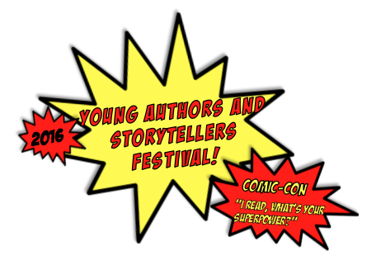

Young Authors & Storytellers Superhero Contest
MMCS c/o (K. Palermo)
30 Bonadonna Avenue
Mt. Morris, NY 14510
(Or bring your design to the festival on April 23, 2016.)

Design A Literary Superhero Contest Submission Form

Name of Superhero:_______________________________________
What are your Superhero’s Powers? ____________________________________________________________________________________________________________________________________________________________
Designer’s Name (First and Last) If this is a class submission please list all who contributed.____________________________________________________________________
Age ______ School _______________________________________ Grade ______
Teacher ____________________________________
Mailing Address __________________________________________
Email Address:___________________________________________
Parent/Guardian Name(s):___________________________________ I/We give permission to Young Authors & Storytellers, Inc. to take and use for marketing purposes submissions for contest (which may include such things as posting the superhero on our Facebook page, displaying it at the Festival, or using it on printed materials.) and understand that no compensation of any form will be made for the superheroes used. _____________________________________
Parent Signature
Check one:
⬜ I am planning to attend the Comicon Festival. (Separate registration required. Registration form will be available March 30.)
⬜ I am sending my superhero, but will not be attending the Festival.

Need to contact us? Kathie kpalermo@mtmorriscsd.org (585)658-3653 or Tracy at (585)507-9813 or peterson@geneseo.edu
or youngauthorsandstorytellers@gmail.com

“This project is made possible with funds from the Decentralization Program, a regrant program of the New York State Council on the Arts with the support of Governor Andrew Cuomo and the New York State Council on the Arts and administered by Livingston Arts, home of The Genesee Valley Council on the Arts.” Due to their generosity, the festival is FREE to all this year.
